**Unit-4**

**Energy Storage**

**Batteries**

**Introduction** A battery consists of two or more electric cells joined together. The cells convert chemical energy to electrical energy. The cells consist of positive and negative electrodes joined by an electrolyte. It is the chemical reaction between the electrodes and the electrolyte which generates DC electricity. In the case of secondary or rechargeable batteries, the chemical reaction can be reversed by reversing the current and the battery returned to a charged state. The ‘lead acid’ battery is the most well known rechargeable type, but there are others. The first electric vehicle using rechargeable batteries preceded the invention of the rechargeable lead acid by quarter of a century, and there are a very large number of materials and electrolytes that can be combined to form a battery. However, only a relatively small number of combinations have been developed as commercial rechargeable electric batteries suitable for use in vehicles. At present these include lead acid, nickel iron, nickel cadmium, nickel metal hydride, lithium polymer and lithium iron, sodium sulphur and sodium metal chloride.

**Overview of Batteries** From the electric vehicle designer’s point of view the battery can be treated as a ‘black box’ which has a range of performance criteria. These criteria will include:

• specific energy

• energy density

• specific power

• typical voltages

• amp hour efficiency

• energy efficiency

• commercial availability

• cost, operating temperatures

• self-discharge rates

• number of life cycles

• recharge rates

The designer also needs to understand how energy availability varies with regard to:

• ambient temperature

• charge and discharge rates

• battery geometry

• optimum temperature

• charging methods

• cooling needs.

However, at least a basic understanding of the battery chemistry is very important, otherwise the performance and maintenance requirements of the different types, and most of the disappointments connected with battery use, such as their limited life, self-discharge, reduced efficiency at higher currents.

**Battery Parameters**

• ***Cell and battery voltages***

All electric cells have nominal voltages which gives the approximate voltage when the cell is delivering electrical power. The cells can be connected in series to give the overall voltage required. The ‘internal resistance’ and the equivalent circuit of a battery is shown in **Figure 1**. The battery is represented as having a fixed voltage *E*, but the voltage at the terminals is a different voltage *V* , because of the voltage across the internal resistance *R*. Assuming that a current *I* is flowing out of the battery, as in Fig. 1, then by basic circuit theory we can say that:

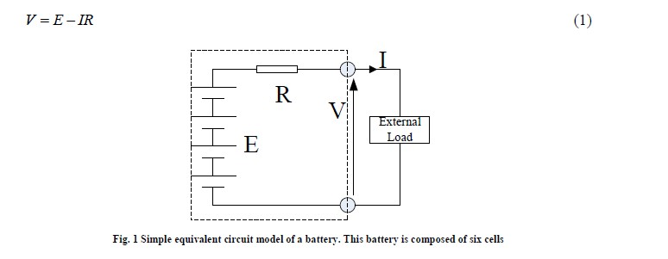

• ***Charge (or Ahr) capacity***

The electric charge that a battery can supply is clearly a most crucial parameter. The SI unit for this is the Coulomb, the charge when one Amp flows for one second. The capacity of a battery might be, say, 10Amphours. This means it can provide 1Amp for 10 hours.

• ***Energy stored***

The energy stored in a battery depends on its *voltage*, and the *charge* stored. The SI unit is the Joule, but this is an inconveniently small unit, and so we use the Whr instead.



***Specific energy***

Specific energy is the amount of electrical energy stored for every kilogram of battery mass. It has units of *Wh.kg−1*.

• ***Energy density***

Energy density is the amount of electrical energy stored per cubic metre of battery volume. It normally has units of *Wh.m−3*.

• ***Specific power***

Specific power is the amount of power obtained per kilogram of battery. It is a highly variable and rather anomalous quantity, since the power given out by the battery depends far more upon the load connected to it than the battery itself.

• ***Ahr (or charge) efficiency***

In an ideal world a battery would return the entire charge put into it, in which case the amp hour efficiency is 100%. However, no battery does; its charging efficiency is less than 100%. The precise value will vary with different types of battery, temperature and rate of charge. It will also vary with the state of charge.

• ***Energy efficiency***

This is another very important parameter and it is defined as the ratio of electrical energy supplied by a battery to the amount of electrical energy required to return it to the state before discharge.

**• Self-discharge rates**

**Most batteries discharge when left unused, and this is known as self-discharge. This is important as it means some batteries cannot be left for long periods without recharging. The rate varies with battery type, and with other factors such as temperature; higher temperatures greatly increase self-discharge.**

• ***Battery temperature, heating and cooling needs***

Although most batteries run at ambient temperature, some run at higher temperatures and need heating to start with and then cooling when in use. In others, battery performance drops off at low temperatures, which is undesirable, but this problem could be overcome by heating the battery. When choosing a battery the designer needs to be aware of battery temperature, heating and cooling needs, and has to take these into consideration during the vehicle design process.

• ***Battery life and number of deep cycles***

Most rechargeable batteries will only undergo a few hundred deep cycles to 20% of the battery charge. However, the exact number depends on the battery type, and also on the details of the battery design, and on how the battery is used. This is a very important figure in a battery specification, as it reflects in the lifetime of the battery, which in turn reflects in electric vehicle running costs.

**Lead Acid Batteries**

• ***Introduction***

The best known and most widely used battery for electric vehicles is the lead acid battery. Lead acid batteries are widely used in IC engine vehicles and as such are well known. However for electric vehicles, more robust lead acid batteries that withstand deep cycling and use a gel rather than a liquid electrolyte are used. These batteries are more expensive to produce. In the lead acid cells the negative plates have a spongy lead as their active material, whilst the positive plates have an active material of lead dioxide. The plates are immersed in an electrolyte of dilute sulphuric acid. The sulphuric acid combines with the lead and the lead oxide to produce lead sulphate and water, electrical energy being released during the process. The overall reaction is:

**D:\dept works\HEV\ehv latest notes screen shots\Screenshot 2022-12-28 142244.jpg**

The reactions on each electrode of the battery are shown in Fig. 2. In the upper part of the diagram the battery is discharging. Both electrode reactions result in the formation of lead sulphate. The electrolyte gradually loses the sulphuric acid, and becomes more dilute. When being charged, as in the lower half of **Figure 2**, the electrodes revert to lead and lead dioxide. The electrolyte also recovers its sulphuric acid, and the concentration rises. The lead acid battery is the most commonly used rechargeable battery in anything but the smallest of systems. The main reasons for this are that the main constituents (lead, sulphuric acid, a plastic container) are not expensive, that it performs reliably, and that it has a comparatively high voltage of about 2V per cell. The overall characteristics of the battery are given in **Table I**. The figure given in **Table I** of 0.022 Ω per cell is a rule of thumb figure taken from a range of good quality traction batteries. A good estimate of the internal resistance of a lead acid battery is thus:

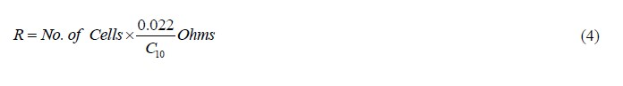

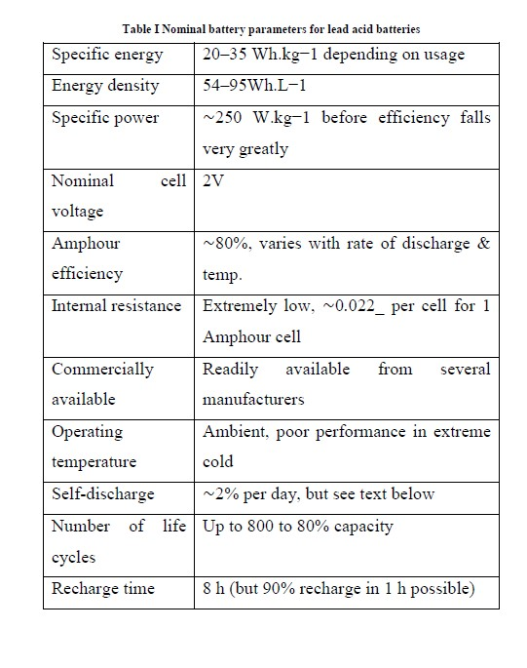

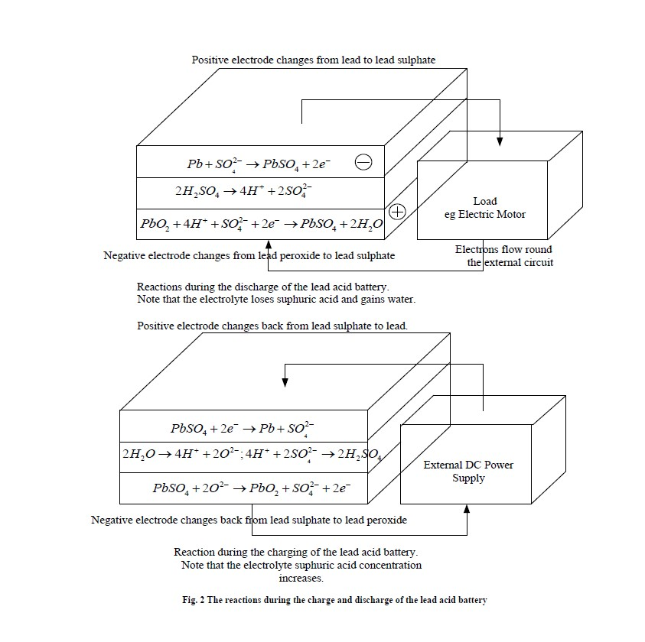

***Battery charging***

Charging a lead acid battery is a complex procedure and, as with any battery, if carried out incorrectly it will quickly ruin the battery and decrease its life. As we have seen, the charging must not be carried out at too high a voltage, or water loss results. There are differing views on the best way of charging lead acid batteries and it is essential that, once a battery is chosen, the manufacturer’s advice is sought. The most commonly used technique for lead acid batteries is called multiple steps charging. In this method the battery is charged until the cell voltage is raised to a predetermined level. The current is then switched off and the cell voltage is allowed to decay to another predetermined level and the current is then switched on again.



**Nickel cadmium batteries**

The nickel–cadmium battery (NiCd battery or NiCad battery) is a type of rechargeable battery which is developed using nickel oxide hydroxide and metallic cadmium as electrodes.

Ni-Cd batteries excel at maintaining voltage and holding charge when not in use. However, NI-Cd batteries worry about “memory” effect when a partially charged battery is recharged, lowering the future capacity of the battery.

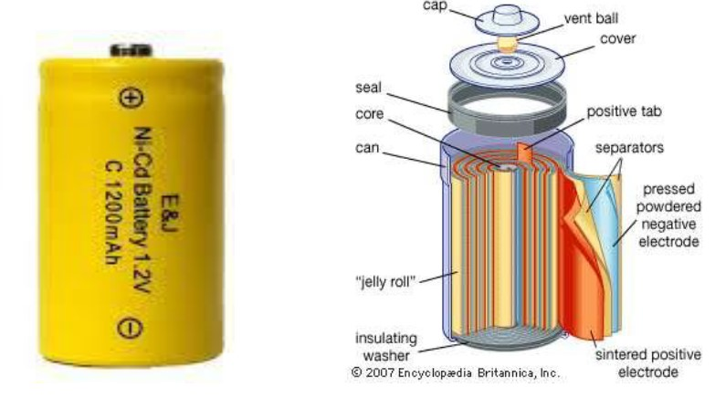

**Electrochemistry**

A fully charged Ni-Cd cell contains:

• a nickel(III) oxide-hydroxide positive electrode plate

• a cadmium negative electrode plate

• a separator, and

• an alkaline electrolyte (potassium hydroxide).

Ni-Cd batteries usually have a metal case with a sealing plate equipped with a self-sealing safety valve.

The positive and negative electrode plates, isolated from each other by the separator, are rolled in a spiral shape inside the case. This is known as the jelly-roll design and allows a Ni–Cd cell to deliver a much higher maximum current than an equivalent size alkaline cell

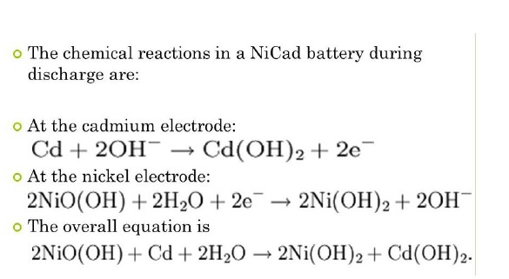

During recharge, the reactions go from right to left. The alkaline electrolyte (commonly KOH) is not consumed in this reaction and therefore its specific gravity, unlike in lead–acid batteries, is not a guide to its state of charge.

Some of the properties of Nickel-Cadmium batteries are listed below.

• Specific Energy: 40-60W-h/kg

• Energy Density: 50-150 W-h/L

• Specific Power: 150W/kg

• Charge/discharge efficiency: 70-90%

• Self-discharge rate: 10%/month

• Cycle durability/life: 2000cycles

**History**

➢ The first Ni–Cd battery was created by waldemar Jungner of Sweden in 1899.

➢ Thomas Edison patented a nickel– or cobalt–cadmium battery in 1902, and adapted the battery design when he introduced the nickel–iron battery to the US two years after Jungner had built one.

➢ In 1906, Jungner established a factory close to Oskarshamn, Sweden to produce flooded design Ni–Cd batteries.

➢ In 1932 active materials were deposited inside a porous nickel-plated electrode and fifteen years later began on a sealed nickel-cadmium battery.

➢ The first production in the United States began in 1946. Up to this point, the batteries were "pocket type," constructed of nickel-plated steel pockets containing nickel and cadmium active materials.

➢ Since the 2000s, all consumer Ni–Cd batteries use the "Swiss roll" or "jelly-roll" configuration. This design incorporates several layers of positive and negative material rolled into a cylindrical shape. This design reduces internal resistance as there is a greater amount of electrode in contact with the active material in each cell Characteristics

➢ The maximum discharge rate for a Ni–Cd battery varies by size. For a common AA-size cell, the maximum discharge rate is approximately 1.8 amperes; for a D size battery the discharge rate can be as high as 3.5 amperes

➢ Model-aircraft or -boat builders often take much larger currents of up to a hundred amps or so from specially constructed Ni–Cd batteries, which are used to drive main motors.

**Properties:**

**Voltage**

Ni–Cd cells have a nominal cell potential of 1.2 volts (V). This is lower than the 1.5 V of alkaline and zinc–carbon primary cells.

Many electronic devices are designed to work with primary cells that may discharge to as low as 0.90 to 1.0 V per cell, the relatively steady 1.2 V of a Ni–Cd cell is enough to allow operation.

Some would consider the near-constant voltage a drawback as it makes it difficult to detect when the battery charge is low.

Ni–Cd batteries used to replace 9 V batteries usually only have six cells, for a terminal voltage of 7.2 volts. While most pocket radios will operate satisfactorily at this voltage.

**Charging**

Ni–Cd batteries can be charged at several different rates, depending on how the cell was manufactured. The charge rate is measured based on the percentage of the amp-hour capacity the battery is fed as a steady current over the duration of the charge.

The safe temperature range when in use is between −20 °C and 45 °C. During charging, the battery temperature typically stays low, around the same as the ambient temperature (the charging reaction absorbs energy), but as the battery nears full charge the temperature will rise to 45–50 °C. Some battery chargers detect this temperature increase to cut off charging and prevent over-charging.

Ni–Cd battery will self-discharge approximately 10% per month at 20 °C, ranging up to 20% per month at higher temperatures. It is possible to perform a trickle charge at current levels just high enough to offset this discharge rate; to keep a battery fully charged

**Overcharging**

Sealed Ni–Cd cells consist of a pressure vessel that is supposed to contain any generation of oxygen and hydrogen gases until they can recombine back to water. Such generation typically occurs during rapid charge and discharge, and exceedingly at overcharge condition. If the pressure exceeds the limit of the safety valve, water in the form of gas is lost. Since the vessel is designed to contain an exact amount of electrolyte this loss will rapidly affect the capacity of the cell and its ability to receive and deliver current. To detect all conditions of overcharge demands great sophistication from the charging circuit and a cheap charger will eventually damage even the best quality cells

➢ **Vented cell batteries**

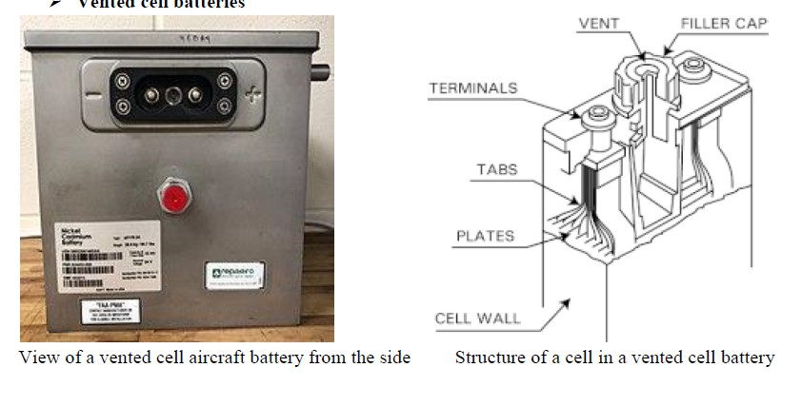

*Vented cell* (*wet cell*, *flooded cell*) NiCd batteries are used when large capacities and high discharge rates are required.

Traditional NiCd batteries are of the sealed type, which means that charge gas is normally recombined and they release no gas unless severely overcharged or a fault develops. Unlike typical NiCd cells, which are sealed, vented cells have a vent or low pressure release valve that releases any generated oxygen and hydrogen gases when overcharged or discharged rapidly.

Since the battery is not a pressure vessel, it is safer, weighs less, and has a simpler and more economical structure.

This also means the battery is not normally damaged by excessive rates of overcharge, discharge or even negative charge.

A steel battery box contains the cells connected in series to gain the desired voltage (1.2 V per cell nominal). Cells are usually made of a light and durable polyamide (nylon), with multiple nickel-cadmium plates welded together for each electrode inside.

A separator or liner made of silicone rubber acts as an insulator and a gas barrier between the electrodes.

Cells are flooded with an electrolyte of 30% aqueous solution of potassium hydroxide (KOH).

The specific gravity of the electrolyte does not indicate if the battery is discharged or fully charged but changes mainly with evaporation of water.

The top of the cell contains a space for excess electrolyte and a pressure release vent. Large nickel-plated copper studs and thick interconnecting links assure minimum equivalent series resistance for the battery.

**Application**

➢ used in photographic equipment, hand-held lamps (flashlight or torch), computer-memory standby

➢ used in cordless and wireless telephones, emergency lighting

➢ Other applications.

Remote-controlled electric model airplanes, boats, and cars, as well as cordless power tools and camera flash units

Eight NiCd batteries in a battery pack

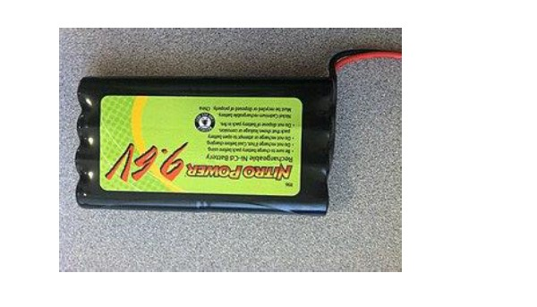

**Nickel Metal Hydride Batteries**

A **nickel metal hydride battery**, abbreviated **NiMH** or **Ni–MH**, is a type of rechargeable battery.

The chemical reaction at the positive electrode is similar to that of the nickel–cadmium cell (NiCd), with both using nickel oxide hydroxide (NiOOH).

However, the negative electrodes use a hydrogen-absorbing alloy instead of cadmium.

A NiMH battery can have two to three times the capacity of an equivalent size NiCd, and its energy density can approach that of a lithium-ion battery.

**NiMH** cells have an alkaline electrolyte, usually potassium hydroxide. The positive electrode is **nickel** hydroxide, and the negative electrode is **hydrogen** in the form of an interstitial **metal hydride**.

***History***

• Work on NiMH batteries began at the Battelle-Geneva Research Center in 1967

• Interest grew in the 1970s with the commercialization of the nickel–hydrogen battery for satellite applications

• In 1987, Willems and Buschow demonstrated a successful battery with high-energy hybrid alloys incorporating rare-earth metals for the negative electrode (using a mixture of La0.8Nd0.2Ni2.5Co2.4Si0.1), which kept 84% of its charge capacity after 4000 charge–discharge cycles.

• The first consumer-grade NiMH cells became commercially available in 1989.

• In 1998, Ovonic Battery Co. improved the Ti–Ni alloy structure and composition and patented its innovations

• In 2008, more than two million hybrid cars worldwide were manufactured with NiMH batteries

• About 22% of portable rechargeable batteries sold in Japan in 2010 were NiMH.

• In Switzerland in 2009, the equivalent statistic was approximately 60%. This percentage has fallen over time due to the increase in manufacture of lithium-ion batteries: in 2000, almost half of all portable rechargeable batteries sold in Japan were NiMH.

• In 2015 BASF produced a modified microstructure that helped make NiMH batteries more durable, in turn allowing changes to the cell design that saved considerable weight, allowing the specific energy to reach 140 watt-hours per kilogram.

• Negative electrode reaction occurring in a NiMH cell is

H2O + M + e− ⇌ OH− + MH

• On the positive electrode, nickeloxyhydroxide, NiO(OH), is formed:

Ni(OH)2 + OH− ⇌ NiO(OH) + H2O + e−

• The reactions proceed left to right during charge and the opposite during discharge. The metal M in the negative electrode of a NiMH cell is an inter metallic compound

Many different compounds have been developed for this application, but those in current use fall into two classes. The most common is AB5, where A is a rare-earth mixture of lanthanum, cerium, neodymium, praseodymium, and B is nickel, cobalt, manganese, or aluminum.

• Some cells use higher-capacity negative electrode materials based on AB2 compounds, where A is titanium or vanadium, and B is zirconium or nickel, modified with chromium, cobalt, iron, or manganese. Any of these compounds serve the same role, reversibly forming a mixture of metal hydride compounds.

• When overcharged at low rates, oxygen produced at the positive electrode passes through the separator and recombines at the surface of the negative. Hydrogen evolution is suppressed, and the charging energy is converted to heat. This process allows NiMH cells to remain sealed in normal operation and to be maintenance-free

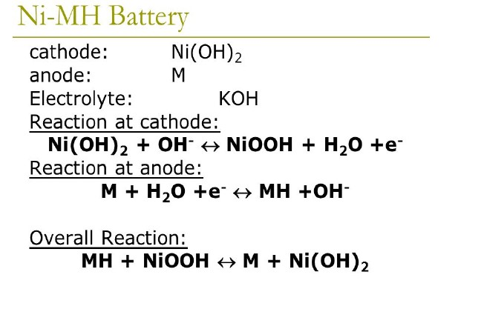

**Properties:**

➢ **Bipolar battery**

NiMH batteries of bipolar design (bipolar batteries) are being developed because they offer some advantages for applications as storage systems for electric vehicles. The solid polymer membrane gel separator could be useful for such applications in bipolar design. In other words, this design can help to avoid short-circuits occurring in liquid-electrolyte systems.

➢ **Charge**

Charging voltage is in the range of 1.4–1.6 V per cell. In general, a constant-voltage charging method cannot be used for automatic charging. When fast-charging, it is advisable to charge the NiMH cells with a smart battery charger to avoid overcharging, which can damage cells

➢ **Trickle charging**

The simplest of the safe charging methods is with a fixed low current, with or without a timer. Most manufacturers claim that overcharging is safe at very low currents, below 0.1 *C* (*C*/10) (where *C* is the current equivalent to the capacity of the battery divided by one hour). The Panasonic NiMH charging manual warns that overcharging for long enough can damage a battery and suggests limiting the total charging time to 10–20 hours.

Panasonic's handbook recommends that NiMH batteries on standby be charged by a lower duty cycle approach, where a pulse of a higher current is used whenever the battery's voltage drops below 1.3 V. This can extend battery life and use less energy.

➢ **Δ*V* charging method**

In order to prevent cell damage, fast chargers must terminate their charge cycle before overcharging occurs. One method is to monitor the change of voltage with time. When the battery is fully charged, the voltage across its terminals drops slightly. The charger can detect this and stop charging. This method is often used with nickel–cadmium cells, which display a large voltage drop at full charge. However, the voltage drop is much less pronounced for NiMH and can be non-existent at low charge rates, which can make the approach unreliable.

Another option is to monitor the change of voltage with respect to time and stop when this becomes zero, but this risks premature cutoffs. With this method, a much higher charging rate can be used than with a trickle charge, up to 1 *C*. At this charge rate, Panasonic recommends to terminate charging when the voltage drops 5–10 mV per cell from the peak voltage. Since this method measures the voltage across the battery, a constant-current (rather than a constant-voltage) charging circuit is used.

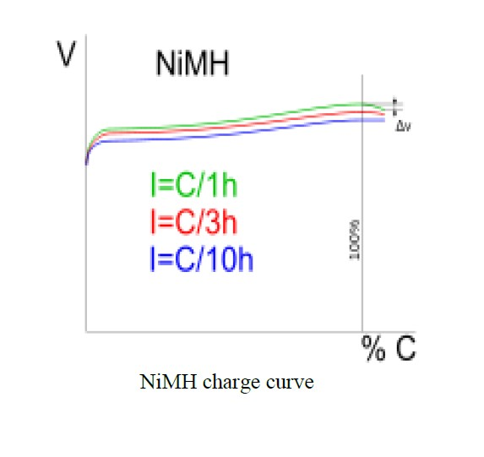

➢ **Δ*T* charging method**

The temperature-change method is similar in principle to the Δ*V* method. Because the charging voltage is nearly constant, constant-current charging delivers energy at a near-constant rate. When the cell is not fully charged, most of this energy is converted to chemical energy. However, when the cell reaches full charge, most of the charging energy is converted to heat. This increases the rate of change of battery temperature, which can be detected by a sensor such as a thermistor. Both Panasonic and Duracell suggest a maximal rate of temperature increase of 1 °C per minute. Using a temperature sensor allows an absolute temperature cutoff, which Duracell suggests at 60 °C. With both the Δ*T* and the Δ*V* charging methods, both manufacturers recommend a further period of trickle charging to follow the initial rapid charge

➢ **Safety**

A resettable fuse in series with the cell, particularly of the bimetallic strip type, increases safety. This fuse opens if either the current or the temperature gets too high.

Modern NiMH cells contain catalysts to handle gases produced by over-charging (2H2+O2 _----catalyst--→ 2H2O). However, this only works with overcharging currents of up to 0.1 *C* (that is, nominal capacity divided by ten hours). This reaction causes batteries to heat, ending the charging process.

A method for very rapid charging called in-cell charge control involves an internal pressure switch in the cell, which disconnects the charging current in the event of overpressure.

One inherent risk with NiMH chemistry is that overcharging causes hydrogen gas to form, potentially rupturing the cell. Therefore, cells have a vent to release the gas in the event of serious overcharging.

NiMH batteries are made of environmentally friendly materials. The batteries contain only mildly toxic substances and are recyclable.

➢ **Loss of capacity**

Voltage depression (often mistakenly attributed to the memory effect) from repeated partial discharge can occur, but is reversible with a few full discharge/charge cycles

➢ **Discharge**

A fully charged cell supplies an average 1.25 V/cell during discharge, declining to about 1.0–1.1 V/cell (further discharge may cause permanent damage in the case of multi-cell packs, due to polarity reversal). Under a light load (0.5 ampere), the starting voltage of a freshly charged AA NiMH cell in good condition is about 1.4

➢ **Over-discharge**

Complete discharge of multi-cell packs can cause reverse polarity in one or more cells, which can permanently damage them. This situation can occur in the common arrangement of four AA cells in series in a digital camera, where one completely discharges before the others due to small differences in capacity among the cells. When this happens, the good cells start to drive the discharged cell into reverse polarity (i.e. positive anode/negative cathode).Some

cameras, GPS receivers and PDAs detect the safe end-of-discharge voltage of the series cells and perform an auto-shutdown, but devices such as flashlights and some toys do not.

Irreversible damage from polarity reversal is a particular danger, even when a low voltage-threshold cutout is employed, when the cells vary in temperature. This is because capacity significantly declines as the cells are cooled. This results in a lower voltage under load of the colder cells.

➢ **Self-discharge**

Historically, NiMH cells have had a somewhat higher self-discharge rate (equivalent to internal leakage) than NiCd cells. The self-discharge rate varies greatly with temperature, where lower storage temperature leads to slower discharge and longer battery life. The self-discharge is 5–20% on the first day and stabilizes around 0.5–4% per day at room temperature. But at 45 °C it is approximately three times as high

➢ **Low self-discharge**

The **low self-discharge nickel metal hydride battery** (**LSD NiMH**) has a significantly lower rate of self-discharge. The innovation was introduced in 2005 by Sanyo, under their Eneloop brand. By using an improved electrode separator and improved positive electrode, manufacturers claim the cells retain 70–85% of their capacity when stored one year at 20 °C (68 °F), compared to about half for normal NiMH batteries. They are otherwise similar to other NiMH batteries and can be charged in typical NiMH chargers. These cells are marketed as "hybrid", "ready-to-use" or "pre-charged" rechargeable

Retention of charge depends in large part on the battery's leakage resistance (the higher the better), and on its physical size and charge capacity.

Separators keep the two electrodes apart to slow electrical discharge while allowing the transport of ionic charge carriers that close the circuit during the passage of current. High-quality separators are critical for battery performance.

Thick separators are one way to reduce self-discharge, but take up space and reduce capacity, while thin separators tend to raise the self-discharge rate. Some batteries may have overcome this tradeoff using thin separators with more precise manufacturing and by using a sulfonated polyolefin separator, a further improvement over the hydrophilic polyolefin based on ethylene vinyl alcohol.

Low-self-discharge cells have lower capacity than standard NiMH cells because of the separator's larger volume. The highest-capacity low-self-discharge AA cells have 2500 mAh capacity, compared to 2700 mAh for high-capacity AA NiMH cells.

**Electric vehicles**

*Main articles: Electric vehicle, Battery electric vehicle*

Prior all-electric plug-in vehicles included the General Motors EV1, first-generation Toyota RAV4 EV, Honda EV Plus, Ford Ranger EV and Vectrix scooter. Every first generation hybrid vehicle used NIMH batteries, most notably the Toyota Prius and Honda Insight, as well as later models including the Ford Escape Hybrid, Chevrolet Malibu Hybrid and Honda Civic Hybrid also use them.

Example battery

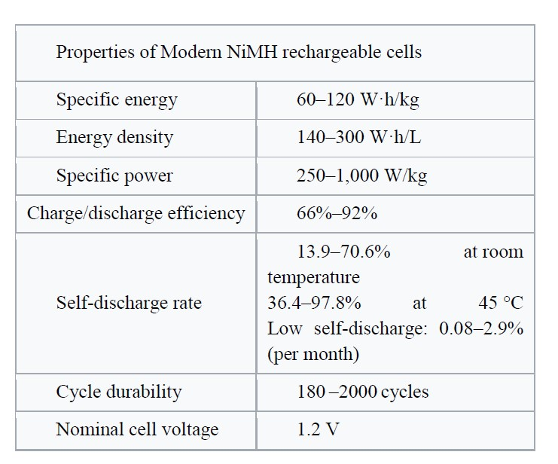

**Lithium Ion batteries**

**Brief History:**

A **lithium-ion battery** or **Li-ion battery** (abbreviated as **LIB**) is a type of rechargeable battery. Lithium-ion batteries are commonly used for portable electronics and electric vehicles and are growing in popularity for military and aerospace applications.

A prototype Li-ion battery was developed by Akira Yoshino in 1985, based on earlier research by John Goodenough, M. Stanley Whittingham, Rachid Yazami and Koichi Mizushima during the 1970s–1980s, and then a commercial Li-ion battery was developed by a Sony and Asahi Kasei team led by Yoshio Nishi in 1991.

In 2019, The Nobel Prize in Chemistry was given to Yoshino, Goodenough, and Whittingham "for the development of lithium ion batteries

**Construction:**

The three primary functional components of a lithium-ion battery are the positive and negative electrodes and electrolyte. Generally, the negative electrode of a conventional lithium-ion cell is made from carbon. The positive electrode is typically a metal oxide. The electrolyte is lithium salt in an organic solvent. The electrochemical roles of the electrodes reverse between anode and cathode, depending on the direction of current flow through the cell.

The most commercially popular anode (negative electrode) is graphite. The positive electrode is generally one of three materials: a layered oxide (such as lithium cobalt oxide), a polyanion (such as lithium iron phosphate) or a spinel (such as lithium manganese oxide). Recently, graphene containing electrodes (based on 2D and 3D structures of graphene) have also been used as components of electrodes for lithium batteries.

The electrolyte is typically a mixture of organic carbonates such as ethylene carbonate or diethyl carbonate containing complexes of lithium ions. These non-aqueous electrolytes generally use non-coordinating anion salts such as lithium hexafluorophosphate(LiPF6), lithium hexafluoroarsenate monohydrate(LiAsF6), lithium perchlorate(LiClO4), lithium tetrafluoroborate (LiBF4), and lithium triflate (LiCF3SO3).

Depending on materials choices, the voltage, energy density, life, and safety of a lithium-ion battery can change dramatically. Current effort has been exploring the use of novel architectures using nanotechnology have been employed to improve performance. Areas on interest include nano-scale electrode materials and alternative electrode structures.[

Pure lithium is highly reactive. It reacts vigorously with water to form lithium hydroxide(LiOH) and hydrogen gas. Thus, a non-aqueous electrolyte is typically used, and a sealed container rigidly excludes moisture from the battery pack.

Lithium-ion batteries are more expensive than NiCd batteries but operate over a wider temperature range with higher energy densities. They require a protective circuit to limit the peak voltage.

The battery pack of a laptop computer, for each lithium-ion cell, will contain

• a temperature sensor

• a voltage regulator circuit

• a voltage tap

• a charge-state monitor

• a mains connector

These components

• monitor the charge-state and current flow

• record the latest, full-charge capacity

• monitor the temperature

• **Charge and discharge**

During discharge, lithium ions (Li+) carry the current within the battery from the negative to the positive electrode, through the non-aqueous electrolyte and separator diaphragm.

During charging, an external electrical power source (the charging circuit) applies an over-voltage (a higher voltage than the battery produces, of the same polarity), forcing a charging current to flow **within the battery** from the positive to the negative electrode, i.e. in the reverse direction of a discharge current under normal conditions. The lithium ions then migrate from the positive to the negative electrode, where they become embedded in the porous electrode material in a process known as intercalation.

Energy losses arising from electrical contact resistance at interfaces between electrode layers and at contacts with current-collectors can be as high as 20% of the entire energy flow of batteries under typical operating conditions.

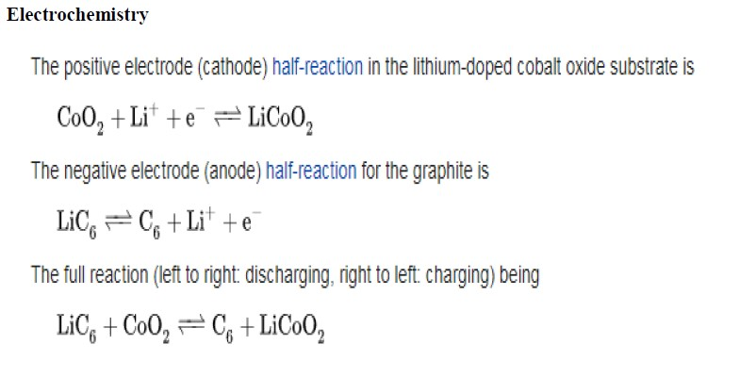

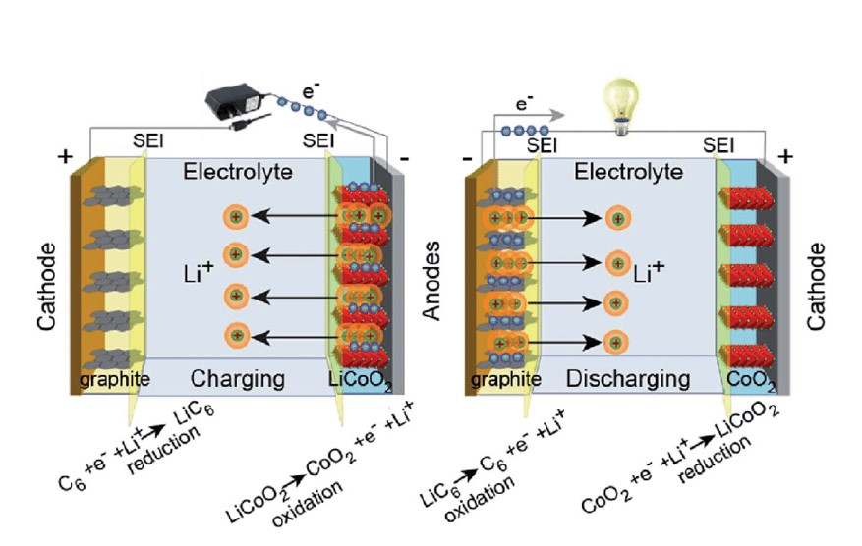

The **charging procedures** for Li-ion batteries:

• **Constant current**

The charger applies a constant current to the battery at a steadily increasing voltage, until the voltage limit per cell is reached.

• **Balance (not required once a battery is balanced)**

The charger reduces the charging current (or cycles the charging on and off to reduce the average current) while the state of charge of individual cells is brought to the same level by a balancing circuit, until the battery is balanced

• **Constant voltage**

The charger applies a voltage equal to the maximum cell voltage times the number of cells in series to the battery, as the current gradually declines towards 0, until the current is below a set threshold of about 3% of initial constant charge current.

**Advantages**

• High energy density - potential for yet higher capacities.

• Does not need prolonged priming when new. One regular charge is all that's needed.

• Relatively low self-discharge - self-discharge is less than half that of nickel-based batteries.

• Low Maintenance - no periodic discharge is needed; there is no memory. Specialty cells can provide very high current to applications such as power tools.

**Limitations**

• Requires protection circuit to maintain voltage and current within safe limits.

• Subject to aging, even if not in use - storage in a cool place at 40% charge reduces the aging effect.

• Transportation restrictions - shipment of larger quantities may be subject to regulatory control. This restriction does not apply to personal carry-on batteries.

• Expensive to manufacture - about 40 percent higher in cost than nickel-cadmium.

• Not fully mature - metals and chemicals are changing on a continuing basis.

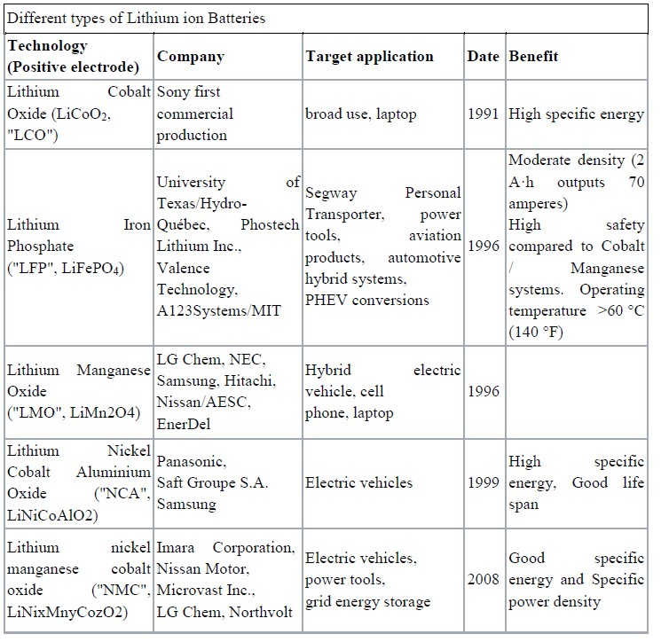

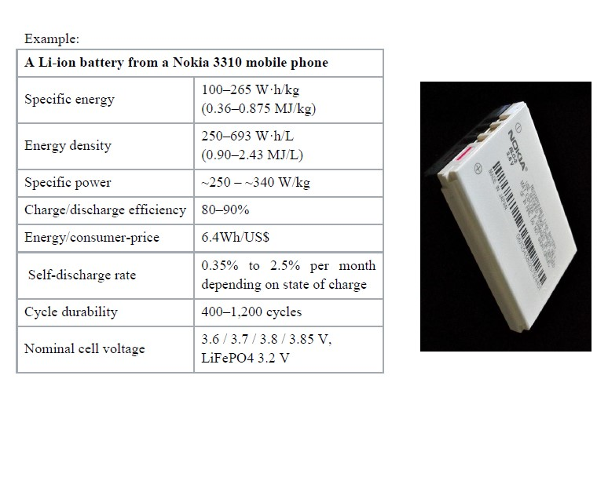

**Fuel Cell**

In this lecture the energy storage (fuel cell) is presented. The following topics are covered in this lecture:

• Fuel cell

• Issues in fuel cell

• Hydrogen fuel cell

• Fuel cell thermodynamics

• Main reasons for loss in voltage

**Fuel Cell *Introduction*** Fuel cells are hardly a new idea. They were invented in about 1840, but they are yet to really make their mark as a power source for electric vehicles. However, this might be set to change over the next 20 or 30 years. Certainly most of the major motor companies are spending very large sums of money developing fuel cell powered vehicles. The basic principle of the fuel cell is that it uses hydrogen fuel to produce electricity in a battery-like device to be explained in the next section. The basic chemical reaction is:

**D:\dept works\HEV\ehv latest notes screen shots\Screenshot 2022-12-29 141631.jpg**

The product is thus water, and energy. Because the types of fuel cell likely to be used in vehicles work at quite modest temperatures (∼85◦C) there is no nitrous oxide produced by reactions between the components of the air used in the cell. A fuel cell vehicle could thus be described as zero-emission. Furthermore, because they run off a fairly normal chemical fuel (hydrogen), very reasonable energies can be stored, and the range of fuel cell vehicles is potentially quite satisfactory. They thus offer the only real prospect of a silent zero-emission vehicle with a range and performance broadly comparable with IC engine vehicles. It is not surprising then that there have, for many years, been those who have seen fuel cells as a technology that shows great promise, and could even make serious inroads into the domination of the internal combustion engine

**Main issues in the fuel cell** There are many problems and challenges for fuel cells to overcome before they become a commercial reality as a vehicle power source. The main problems centre on the following issues.

• *Cost:* Fuel cells are currently far more expensive than IC engines, and even hybrid IC/electric systems.

• *Water management:* It is not at all self-evident why water management should be such an important and difficult issue with automotive fuel cells.

• *Cooling:* The thermal management of fuel cells is actually rather more difficult than for IC engines.

• *Hydrogen supply:* Hydrogen is the preferred fuel for fuel cells, but hydrogen is very difficult to store and transport. There is also the vital question of ‘where does the hydrogen come from’ these issues are so difficult and important, with so many rival solutions.

However, there is great hope that these problems can be overcome, and fuel cells can be the basis of less environmentally damaging transport.

**Hydrogen Fuel Cells: Basic Principles** *Electrode reactions* We have seen that the basic principle of the fuel cell is the release of energy following a chemical reaction between hydrogen and oxygen. The key difference between this and simply burning the gas is that the energy is released as an electric current, rather that heat. How is this electric current produced? To understand this we need to consider the separate reactions taking place at each electrode. These important details vary for different types of fuel cell, but if we start with a cell based on an acid electrolyte, we shall consider the simplest and the most common type. At the anode of an acid electrolyte fuel cell the hydrogen gas ionizes, releasing electrons and creating H+ ions (or protons)

**D:\dept works\HEV\ehv latest notes screen shots\Screenshot 2022-12-29 141755.jpg**

This reaction releases energy. At the cathode, oxygen reacts with electrons taken from the electrode, and H+ ions from the electrolyte, to form water.



Clearly, for both these reactions to proceed continuously, electrons produced at the anode must pass through an electrical circuit to the cathode. Also, H+ ions must pass through the electrolyte. An acid is a fluid with free H+ ions, and so serves this purpose very well. Certain polymers can also be made to contain mobile H+ ions.

*Different electrolytes*

The reactions given above may seem simple enough, but they do not proceed rapidly in normal circumstances. Also, the fact that hydrogen has to be used as a fuel is a disadvantage. To solve these and other problems many different fuel cell types have been tried. The different types are usually distinguished by the electrolyte that is used, though there are always other important differences as well

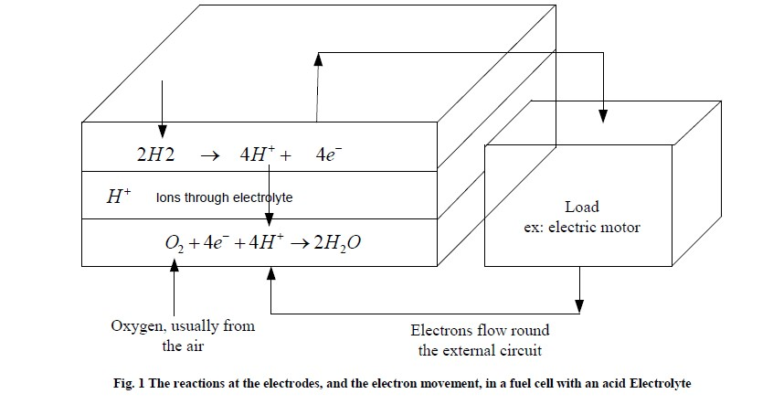

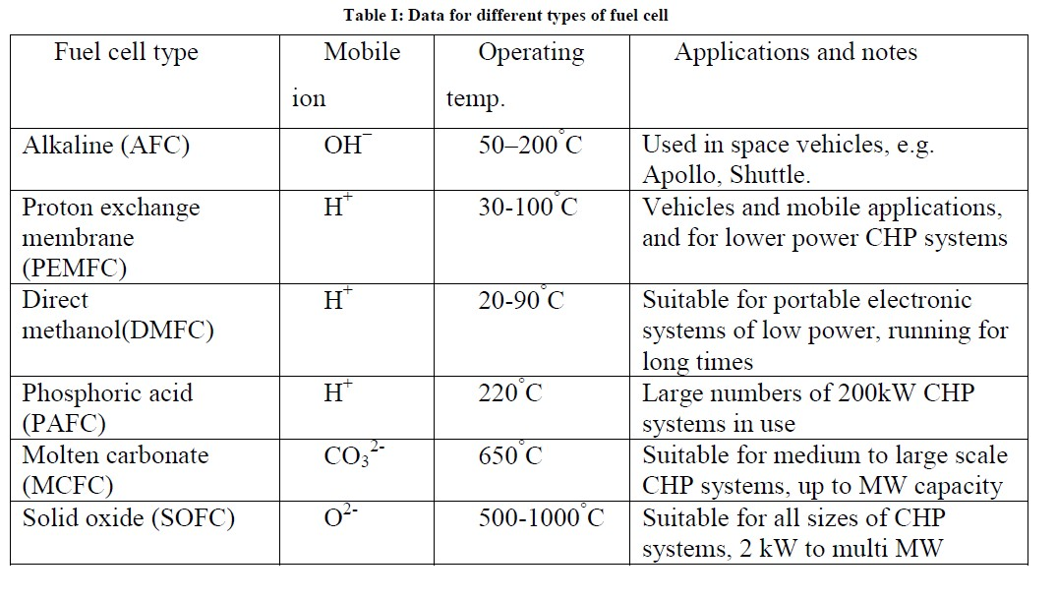

The situation now is that six classes of fuel cell have emerged as viable systems for the present and near future. Basic information about these systems is given in Table I. As well as facing up to different problems, the various fuel types also try to play to the strengths of fuel cells in different ways. The PEM fuel cell capitalizes on the essential simplicity of the fuel cell. The electrolyte is a solid polymer, in which protons are mobile. The chemistry is the same as the acid electrolyte fuel cell of Fig. 1. With a solid and immobile electrolyte, this type of cell is inherently simple; it is the type that shows by far the most promise for vehicles, and is the type used on all the most impressive demonstration fuel cell vehicles. This type of fuel cell is the main focus of this chapter. PEM fuel cells run at quite low temperatures, so the problem of slow reaction rates has to be addressed by using sophisticated catalysts and electrodes. Platinum is the catalyst, but developments in recent years mean that only minute amounts are used, and the cost of the platinum is a small part of the total price of a PEM fuel cell

One theoretically very attractive solution to the hydrogen supply problem is to use methanol1 as a fuel instead. This can be done in the PEM fuel cell, and such cells are called direct methanol fuel cells. ‘Direct’ because they use the methanol as the fuel as it is, in liquid form, as opposed to extracting the hydrogen from the methanol using one of the methods. Unfortunately these cells have very low power, and for the foreseeable

future at least their use will be restricted to applications requiring slow and steady generation of electricity over long periods. A demonstration DMFC powered go-kart has been built, but really the only likely application of this type of cell in the near future is in the rapidly growing area of portable electronics equipment. Although PEM fuel cells were used on the first manned spacecraft, the alkaline fuel cell was used on the Apollo and is used on the Shuttle Orbiter. The problem of slow reaction rate is overcome by using highly porous electrodes, with a platinum catalyst, and sometimes by operating at quite high pressures. Although some historically important alkaline fuel cells have operated at about 200◦C, they more usually operate below 100◦C. The alkaline fuel cell has been used by a few demonstration electric vehicles, always in hybrid systems with a battery. They can be made more cheaply than PEMFCs, but they are lower in power, and the electrolyte reacts with carbon dioxide in the air, which make terrestrial applications difficult.

*Fuel cell electrodes*

Fig. 2 is another representation of a fuel cell. Hydrogen is fed to one electrode, and oxygen, usually as air, to the other. A load is connected between the two electrodes, and current flows. However, in practice a fuel cell is far more complex than this. Normally the rate of reaction of both hydrogen and oxygen is very slow, which results in a low current, and so a low power. The three main ways of dealing with the slow reaction rates are: the use of suitable catalysts on the electrode, raising the temperature, and increasing the electrode area. The first two can be applied to any chemical reaction. However, the third is special to fuel cells and is very important. If we take a reaction such as that of Eq. 3, we see that oxygen gas, and H+ ions from the electrolyte, and electrons from the circuit are needed, all three together. This ‘coming together’ must take place on the surface of the electrode. Clearly, the larger the electrode area, the more scope there is for this to happen and the greater the current. This is very important. Indeed, electrode area is such a vital issue that the performance of a fuel cell design is often quoted in terms of the current *per cm2.*

The structure of the electrode is also important. It is made highly porous so that the real surface area is much greater than the normal length × width. As well as being of a large surface area, and highly porous, a fuel cell electrode must also be coated with a catalyst layer. In the case of the PEMFC this is platinum, which is highly expensive. The catalyst thus needs to be spread out as finely as possible. This is normally done by supporting very fine particles of the catalyst on carbon particles.

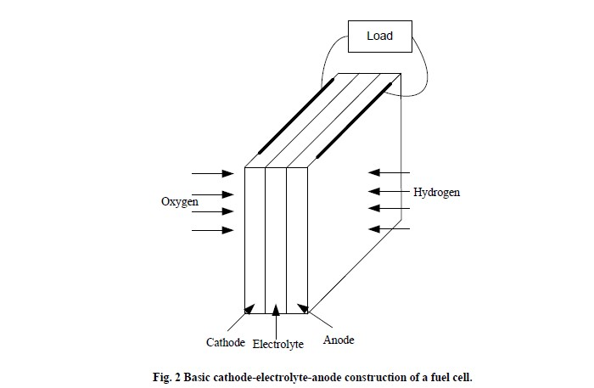

The reactants need to be brought into contact with the catalyst, and a good electrical contact needs to be made with the electrode surface. Also, in the case of the cathode, the product water needs to be removed. These tasks are performed by the ‘gas diffusion layer’, a porous and highly conductive material such as carbon felt or carbon paper, which is layered on the electrode surface

**Fuel Cell Thermodynamics – Introduction**

*Fuel cell efficiency and efficiency limits* One of the attractions of fuel cells is that they are not heat engines. Their thermodynamics are different, and in particular their efficiency is potentially greater as they are not limited by the well-known Carnot limit that impinges on IC and other types of fuel burning engines. However, as we shall see, they do have their own limitations, and while fuel cells are often more efficient than IC engines, the difference is sometimes exaggerated.

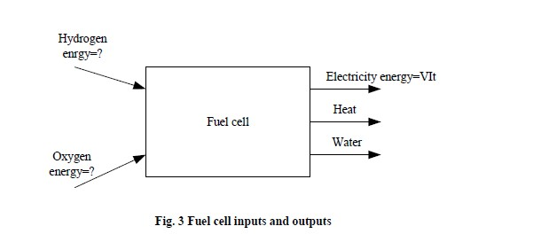

At first we must acknowledge that the efficiency of a fuel cell is not straightforward to define. In some electrical power generating devices it is very clear what form of energy is being converted into electricity. With a fuel cell such energy considerations are much more difficult to visualize. The basic operation has already been explained, and the input and outputs are shown in Fig. 3. The electrical power and energy output are easily calculated from the well known formulas:

D:\dept works\HEV\ehv latest notes screen shots\Screenshot 2022-12-29 143050.jpg

However, the energy of the chemical inputs and output is not so easily defined. At a simple level we could say that it is the chemical energy of the H2, O2 and H2O that is in question. The problem is that chemical energy is not simply defined, and terms such as enthalpy, Helmholtz function and Gibbs free energy are used. In recent years the useful term ‘energy’ has become quite widely used, and the concept is particularly useful in high temperature fuel cells, though we are not concerned with these here. There are also older (but still useful) terms such as calorific value

In the case of fuel cells it is the Gibbs free energy that is important. This can be defined as the energy available to do external work, neglecting any work done by changes in pressure and/or volume. In a fuel cell the external work involves moving electrons round an external circuit; any work done by a change in volume between the input and output is not harnessed by the fuel cell. Energy is *all* the external work that can be extracted, including that due to volume and pressure changes. Enthalpy, simply put, is the Gibbs free energy plus the energy connected with the entropy. The enthalpy *H*, Gibbs free energy *G* and entropy *S* are connected by the well-known equation:

D:\dept works\HEV\ehv latest notes screen shots\Screenshot 2022-12-29 143152.jpg

The energy that is released by a fuel cell is the change in Gibbs energy before and after a reaction, so the energy released can be represented by the equation:

D:\dept works\HEV\ehv latest notes screen shots\Screenshot 2022-12-29 143224.jpg

However, the Gibbs free energy change is *not constant*, but changes with temperature and state (liquid or gas). Table II below shows *ΔG* for the basic hydrogen fuel cell reaction for a number of different conditions. Note that the values are negative, which means that energy is released.



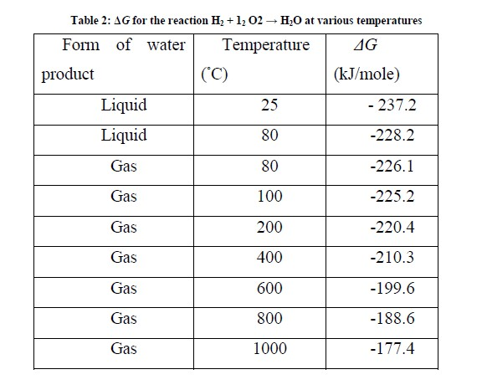

If there are no losses in the fuel cell, or as we should more properly say, if the process is reversible, then all this Gibbs free energy is converted into electrical energy. We could thus define the efficiency of a fuel cell as:



Since a fuel cell uses materials that are usually burnt to release their energy, it would make sense to compare the electrical energy produced with the heat that would be produced by burning the fuel. This is sometimes called the calorific value, though a more precise description is the change in enthalpy of formation. Its symbol is *ΔH*. As with the Gibbs free energy, the convention is that Δ*H* is negative when energy is released. So to get a good comparison with other fuel using technologies, the efficiency of the fuel cell is usually defined as:



However, even this is not without its ambiguities, as there are two different values that we can use for *ΔH*. For the burning of hydrogen

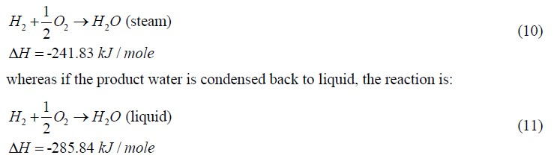

The difference between these two values for *ΔH* (44.01 kJ/mole) is the molar enthalpy of vaporization of water. The higher figure is called the higher heating value (HHV), and the lower, quite logically, the lower heating value (LHV). Any statement of efficiency should say whether it relates to the higher or lower heating value. If this information is not given, the LHV has probably been used, since this will give a higher efficiency figure.

We can now see that there is a limit to the efficiency, if we define it as in Eq. 4. The maximum electrical energy available is equal to the change in Gibbs free energy, so:



This maximum efficiency limit is sometimes known as the thermodynamic efficiency. Table III gives the values of the efficiency limit, relative to the higher heating value, for a hydrogen fuel cell. The maximum voltage obtainable from a single cell is also given. The graphs in Fig. 5 show how these values vary with temperature, and how they compare with the Carnot limit, which is given by the equation:

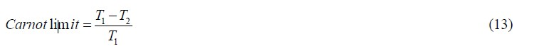where *T*1 is the higher temperature, and *T*2 the lower, of the heat engine. The graph makes clear that the efficiency limit of the fuel cell is certainly not 100%, as some supporters of fuel cells occasionally claim. Indeed, above the 750◦C the efficiency limit of the hydrogen fuel cell is actually less than for a heat engine. Nevertheless, the PEM fuel cells used in vehicles operate at about 80◦C, and so their theoretical maximum efficiency is actually much better than for an IC engine.

**Hybridization of Energy Storages**

Concept of Hybrid Energy Storage

The hybridization of energy storage involves to combining two or more energy storages together so that the advantages of each can be brought out and the disadvantages can be compensated by others. For instance, the hybridization of a chemical battery with an ultracapacitor can overcome problems such as the low specific power of chemical batteries and low specific energy of ultracapacitors, thus achieving high specific energy and high specific power. Basically, the hybridized energy storage consists of two basic energy storages, one with high specific energy and the other with high specific power.

The basic operation of this system is illustrated in Figure 12.18. In highpower demand operation, such as acceleration and hill climbing, both basic energy storages deliver their power to the load as shown in Figure 12.18a. On the other hand, in low-power demand operation, such as constant-speed cruising operation, the high specific energy storage will deliver its power to the load and charge the high specific power storage to recover its charge lost during high-power demand operation, as shown in Figure 12.18b.

In regenerative braking operation, the peak power will be absorbed by the high specific power storage, and only a limited part is absorbed by the high specific energy storage. In this way, the whole system would be much smaller in weight and size than if any one of them alone was the energy storage.

**Passive and Active Hybrid Energy Storage with**

**Battery and Ultracapacitor**

Based on the available technologies of various energy storages, there are

several viable hybridization schemes for EVs and HEVs: typically, battery

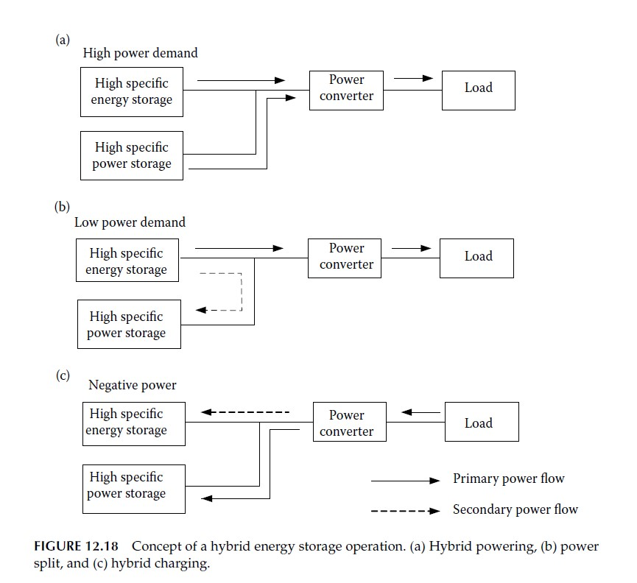

and battery hybrids, and battery and ultracapacitor hybrids. The latter is more natural because the ultracapacitor can offer a much higher power than batteries, and it collaborates with various batteries to form the battery and ultracapacitor hybrids. During the hybridization, the simplest way is to directly and parallelly connect the ultracapacitors to the batteries as shown inFigure 12.19.

In this configuration, the ultracapacitors simply act as a current filter, which can significantly level the peak current of the batteries and reduce the battery voltage drop as shown in Figures 12.20 and 12.21. The major disadvantages of this configuration are that the power flow cannot be actively controlled and the ultracapacitor energy cannot be fully used. Figure 12.22 shows a configuration in which a two-quadrant DC/DC converter is placed between the batteries and ultracapacitors. This design allows the batteries and the ultracapacitors to have a different voltage; also the power flow between them can be actively controlled and the energy in the ultracapacitors can be fully used. In the long term, an ultra-high-speed flywheel will replace the batteries in hybrid energy storage to obtain a high efficiency, compact, and long-life storage system for EVs and HEVs.

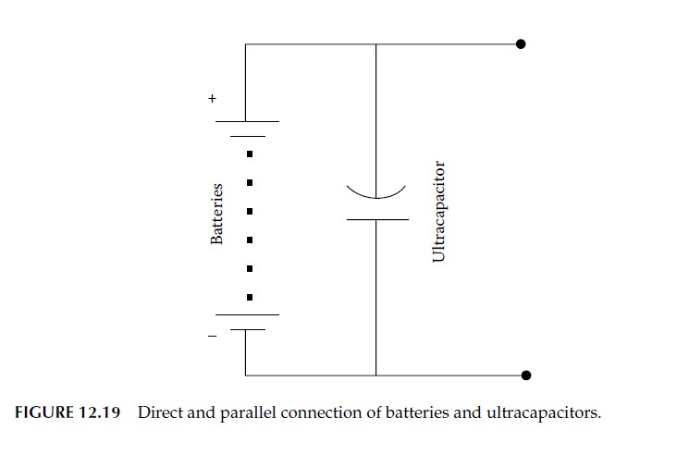

Battery and Ultracapacitor Size Design The best design of a hybrid energy storage with a battery and an ultracapacitor is that the overall energy and power capacities just meet the energy and power requirements of the vehicle without much margins.8 The energy and power requirements of a vehicle to its energy storage can be represented by the

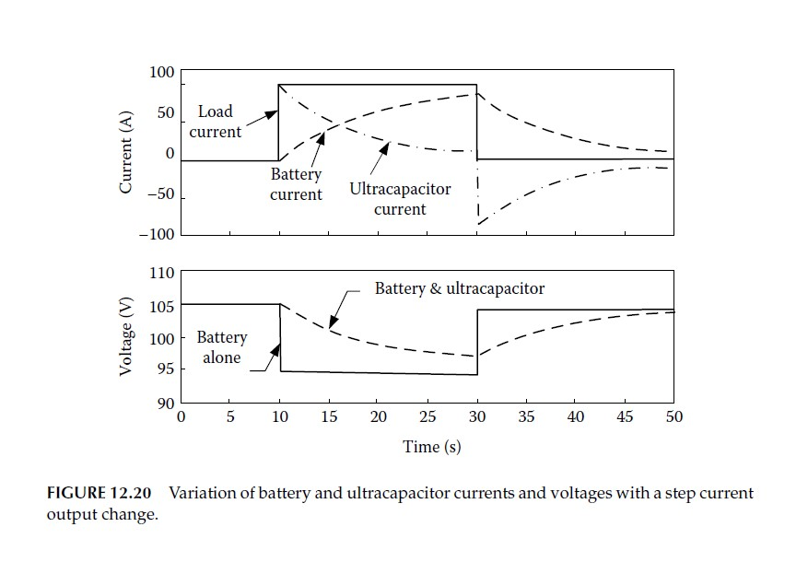

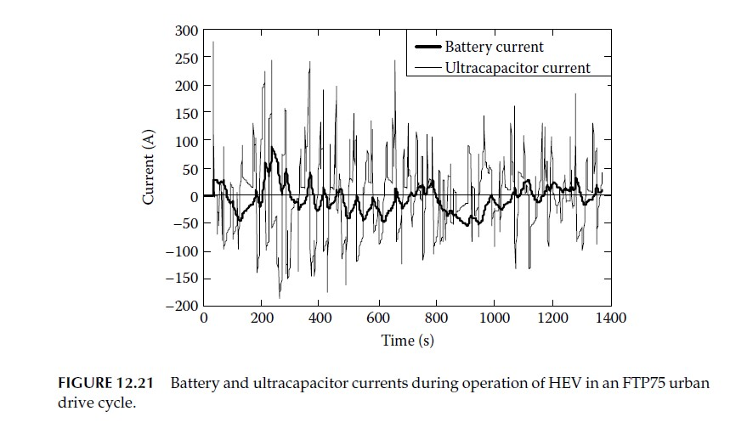

energy/power ratio, which is defined as



where *E*r and *P*r are the energy and power required by the vehicle, respectively.

The energy and power requirements mostly depend on the design of the vehicle drive train and control strategy as discussed in Chapters 7 through 9. When *R*e*/*p is known, the battery and ultracapacitor in the hybrid storage can

be designed so that the energy/power ratio of the hybrid energy storage is

equal to *R*e*/*p, which is expressed as8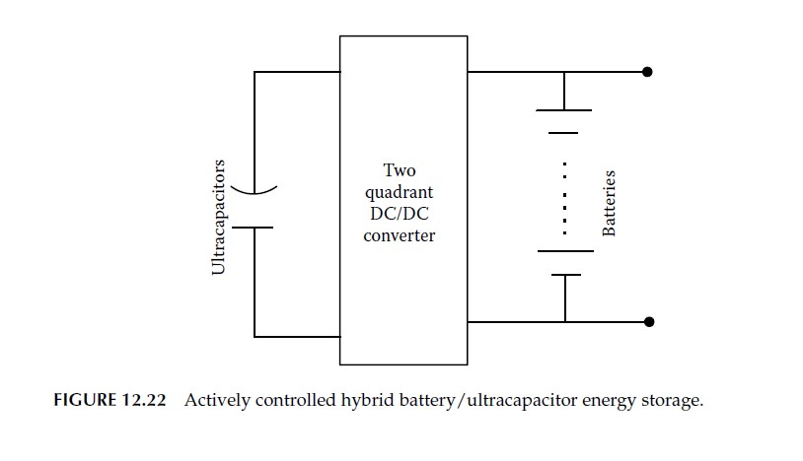



where *W*b and *W*c are the weights of the battery and ultracapacitor, respectively,

*E*b and *E*c are the specific energies of the battery and ultracapacitor,

respectively, and *P*b and *P*c are the specific powers of the battery and

ultracapacitor, respectively.

Equation 12.50 can be further written as

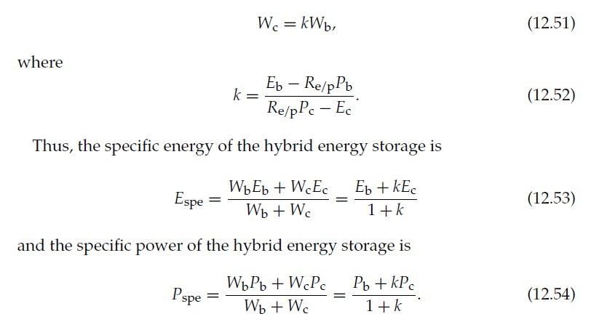

An example is shown in the following.

Suppose that a vehicle needs a 50-kW energy storage; the desired

energy/power ratio *R*e*/*p = 0.07 h, that is, 3.5-kWh energy is required and the

battery and ultracapacitor characteristics are shown in Tables 12.5 and 12.6.

The weights needed for a single source and hybrid sources are listed in

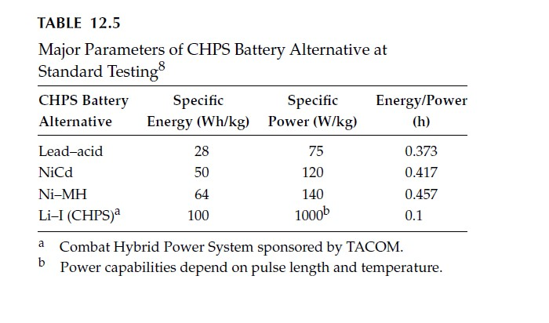

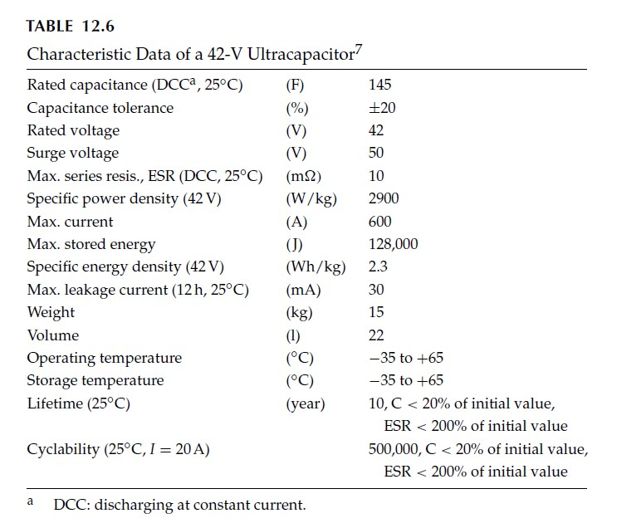

Tables 12.7 and 12.8. Comparing the total weights in Tables 12.7 and 12.8,

it is obvious that the hybrid energy storage can save the weight significantly,

especially with a battery that has low power density.

